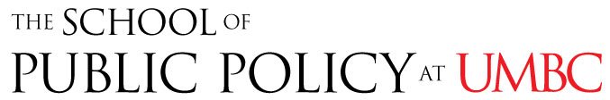

PUBL 610-05. Demographic Issues and Public Policy
Dr. John Rennie Short, School of Public Policy
(jrs@umbc.edu)
Fall 2019: Wednesdays, 4:30-7:00 PM

This course looks at how demographic trends influence and shape public debates and policies. It examines policies across the demographic transition, from rapidly growing to maturing and ageing societies. Specific issues covered include youth unemployment, harvesting the demographic dividend and coping with a greying society. This cross cultural course, looking at countries as diverse as Japan, USA, Vietnam, and Russia will appeal to student with a variety of interests.

PUBL 648. Cities and Environmental Issues
Dr. John Rennie Short, School of Public Policy
(jrs@umbc.edu)
Fall 2019: Wednesdays, 7:10-9:40 PM

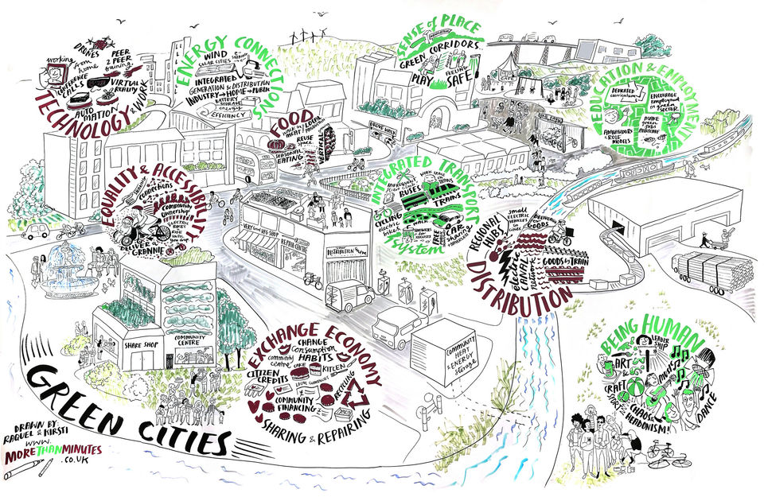

This course is built around the assertion that the city is part of the environment, subject to environmental constraints and opportunities. The city has been treated in most social science writings as a purely social phenomenon, and at the same time, many environmental scientists have tended to ignore the urban. This course aims to reconnect natural science and social science through the examination of the urban environment.

PUBL 636. Law, Politics, and Educational Policy
Dr. Pamela R. Bennett, School of Public Policy
(pbennett@umbc.edu)
Fall 2019: Mondays, 7:10-9:40 PM

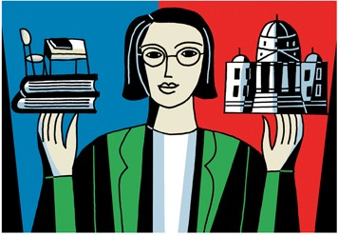

This course examines the ways in which educational policy is created and implemented through the political process and America's legal system. Attention will be paid to the distribution of power between affected groups and value conflicts reflected in educational policy debates. Topics include students' rights, academic freedom, sexual harassment and assault policies, school desegregation, school finance and equity, urban school governance, school choice, school safety, and the politics of higher education among others.

PUBL 610-01. Urban Sociology and Urban Policy
Dr. Pamela R. Bennett, School of Public Policy
(pbennett@umbc.edu)
Fall 2019: Thursdays, 4:30-7:00 PM
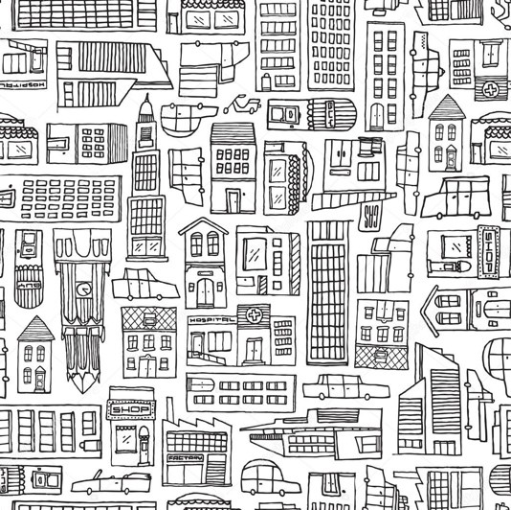

This course considers the ways in which sociology (and other disciplines) study the social and economic organization of cities, the ways in which that organization affects urban life, and how cities, in turn, are shaped by the social and economic dynamics that take place within them. The course begins with an examination of the major theoretical perspectives (and debates) used to examine these themes (e.g., the Chicago School and its ecological approach, new urban sociology and its political economy approach). We then explore social processes and institutions that generate and reflect inequalities in cities (e.g., segregation, suburbanization, ghettos), and consider how lifestyle and consumption patterns create urban change. Attention is given to policy issues throughout.

PUBL 652. Politics of Health
Dr. Nancy Miller, School of Public Policy
(nanmille@umbc.edu)
Fall 2019: Tuesdays 7:10-9:40 PM

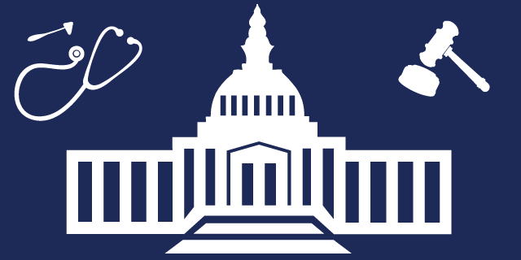

The U.S. spent $3.5 trillion on health care in 2017, just under 18% of the U.S. gross domestic product. Health care as a policy issue touches everyone and is a top-ranked concern in national polls. It has continuing visibility given court decisions related to the constitutionality of the 2010 Affordable Care Act (ACA). Efforts to strengthen the ACA as well as to develop new approaches to delivering health care are central issues in many of the current Democratic presidential candidates’ platforms, while President Trump and many Republicans continue to seek to repeal the ACA. This course is designed to help students understand how and why health policies like the ACA reflect the political system in which they are enacted and implemented.

