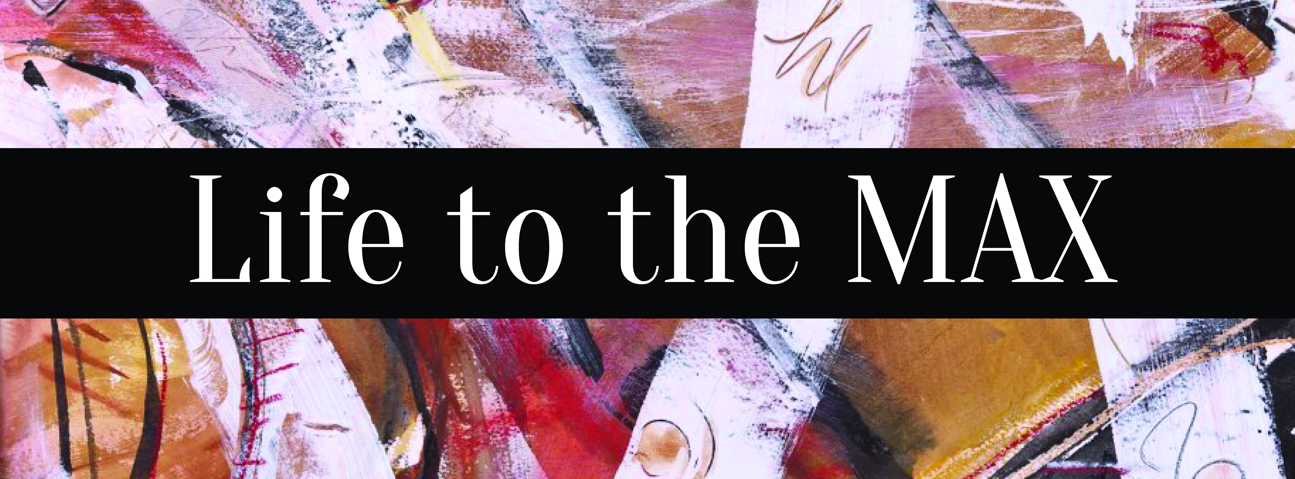

**Exhibit Open: Dec. 5-13, 2014**

**Public Reception: Friday, Dec. 5, 6:00-8:00pm**

**Kerplunk!: Sat., Dec. 9, 12:00-3:00 pm—Free Family Drop-In Program**

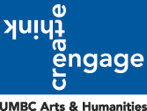

**About the Exhibit**

*Life to the MAX*is an exploration of the mundane with an abstract twist. The exhibition, featuring artist, Maxine Taylor, seeks to bring viewers face to face with a unique interpretation of everyday occurrences. Each of the Taylor’s 12 paintings in the show tells a distinctive story through bold lines, warm colors, and commonplace titles showcasing Taylor’s signature abstract style. The show runs**December 5-13, 2014** and includes a reception with the artist on **Friday, December 5, 6:00-8:00 pm**. The event is free and open to the public with light refreshments and features a brief talk led by the student curators.

**Programming**

Programming includes an opportunity for families and children of all ages to create their own abstract artwork. As part of the Creative Alliance’s regularly scheduled Kerplunk! Family Art Drop-In on **Saturday, November 22, 12:00-3:00 pm**, all families are invited to participate free of charge. Participants’ artwork created on Nov. 22nd will be incorporated into a collaborative installation inspired by the artist.

**UMBC Student Curators**

*Life to the MAX* is curated by students from the University of Maryland, Baltimore County as a final project for Sandra Abbott’s Museum Practice course. The class is comprised of a combination of Undergraduate and Graduate students from a variety of disciplines. The student curators include Sienna Cureton-Mahoney, Katherine Fusick, Diana Harris, Phillip Howden, Giuseppe Luciani, Cara McGaughran, Alexander Merkle, and Alexandra Riggin.

*Life to the MAX* and associated programs are supported in part by the UMBC Department of Visual Arts. Printing services for the exhibit were donated by commonvision: UMBC Design and Print Center.

**For more information please visit:**

[www.creativealliance.org](http://www.creativealliance.org/) or <https://www.facebook.com/events/816254345092562/?ref=notif&notif_t=plan_user_invited>

The exhibition and programs are supported in part by the College of

Arts, Humanities, and Social Sciences and the Department of Visual Arts.