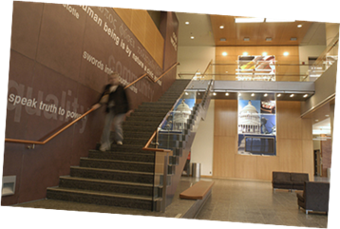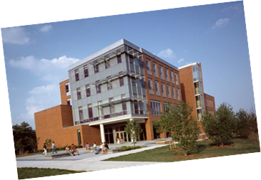
MONDAYS @ 12 PM PUP 204

“It’s never too late or too early to get involved”

- Opportunity to meet and share information | - Discuss mutual interests.
- Resource of students seeking information regarding post-graduation goals | - Career networking and guidance with graduate school programs.
- Community Outreach Events | - Extra Credit Possibilities

For The Latest HAPP COM News

Join the Council of Majors MyUMBC Group page.

1. Sign in to your MyUMBC
2. Go to the Community drop down arrow
3. Select group
4. Search Health
5. Select HAPP COM & Join the group.

HAPP COM OFFICERS
David Edwards  davide1@umbc.edu  President | Yasmin Teymourian  tyas1@umbc.edu  Vice President
Alana Moore  alana5@umbc.edu  Secretary | Oriaku Okpa  ookpa1@umbc.edu  Treasurer
Nikita Bhandari
nbhanda1@umbc.edu
Public Relations Chair

