THE RETRIEVER PROJECT:
Statue Design Contest Info & Application
Every dog has a tale… share yours!

WHAT IS THIS, ALREADY?!
In fall 2011, a couple of students took a class about civic agency and social entrepreneurship. We were asked how we wanted to see the UMBC campus changed for the better. We decided that we wanted to see the school spirit and pride that each Retriever carried with him or her. As a result, The Retriever Project was born and is now finally being initiated as a SGA 2012 Prove-It winner.

The Retriever Project is a UMBC campus-wide, public art initiative created to celebrate and display the dynamic, unique culture of UMBC. To put it shortly, in spring 2013, three new beautifully designed Retriever statues will be displayed around the UMBC campus, such as in front of the Library or on Academic Row. Starting this fall 2012, the statue design contest begins on October 10, 2012 through November 21, 2012. After the final deadline, all of the designs are considered and voted upon by The Retriever Project Advisory Committee. The winners will then be announced! In the winter months between December and February, the statues will be painted by UMBC art majors. Finally, when the statues are all painted, they will be revealed in March-April of 2013. Statues will remain on campus for two years. The statues will remain on campus through spring 2014, when they will then be moved indoors or to other off-campus locations according to community partnerships. The process will begin all over again in fall 2014!

WHO CAN BE A PARTICIPANT?!
The contest is open to all UMBC community members, including students, faculty, and staff. You may apply as an individual, or if you and a group get together, even better! This is your opportunity to show us your retriever pride and leave your legacy here on campus!

WHEN IS THIS HAPPENIN’?!
October 10, 2012- October 12, 2012 Homecoming Week kick-off begins in the Breezeway at 11a-2p. The application deadline is November 21, 2012 at 12:00pm.

HOW DO I GET INVOLVED?!
It’s pretty easy! Using the design templates provided below, create a design to be painted on the retriever statue. Our question to you is: what does it mean to be a Retriever at UMBC? Your design should answer this question by representing a story or value(s) of the UMBC community. You are not designing the shape of the actual statue, but rather the art design that will be painted onto the retriever statue. Complete a design on all three dog forms of the design templates and ensure that any overlapping spaces between the three sections of the templates are consistent in the design. You must have a creative title for your statue and include it below. Finally, please include/ attach a short (few paragraphs) explanation of your design and how you believe it is representative of the UMBC community and answers the question: what does it mean to be a Retriever at UMBC? This short explanation will be used during the judging and voting of your application and design!
Contest Details: Three retriever statue designs will be selected by the Retriever Statue Advisory Committee and all decisions are final. The winning statue designs will be painted by pre-determined painters and then sealed over with a weather-proof seal. All finished retriever statues will have an accompanying plaque that recognizes the name of the original artist(s) and painter(s). All submitted retriever statue designs will be considered by the Retriever Statue Design Committee. You may submit more than one design per person or group; however, the Design Committee reserves the right to select only one design per artist/ group.

WHERE DO I SUBMIT MY AWESOME APPLICATION/ DESIGN?!
Finished design packets and signed Copyright Agreements can be scanned and emailed to kelkra1@umbc.edu or returned in paper copy to the SGA Office, located on the Second floor of the Commons, off of the Student Organization Space (SOS), in the box marked “Retriever Statue Design Finished Applications.” All other questions can be emailed to kelkra1@umbc.edu. Please be sure to label the subject line as: Retriever Project Inquiries/Questions/Issues. Thanks!

SO, WHAT’S LEFT?!
Not much more before you can begin designing!
- We need your signature a few times and some of your information for us to keep track of all the submissions.
- The following pages have all of the information that we need- please be sure to fill out the application entirely! We do not want to disqualify anyone because of an incomplete application.
- If you decide to turn-in your application in a paper copy, please print only pages 3-9 so that we save some trees!
- If you decide to turn-in your application via email, feel free to edit this document. Save it as your full name with TRP at the end: (FIRSTLASTNAME-TRP). Please be sure to email it to kelkra1@umbc.edu with the subject label as: The Retriever Project Application submitted by (your awesome name here!)
- For group submissions- be sure to give each person credit! As well, each person involved in the design creation process must complete an attached copyright assignment and include it with the application packet.

FINALLY, HOW DO I GET MY DESIGN ON?!
The dog outlines below are the templates which you will be working with. Be sure to design inside the lines of each template. You are welcome to open this design within Adobe Photoshop, Adobe Illustrator, or Microsoft Publisher. When you submit on-line, please put the design in a PDF format or we will not accept it. If you print out a design created on the computer, it does not matter which format the design is in. Please do NOT change the template size. Please leave it the size of the full-page paper. To give you some perspective, the approximate dimensions of the retriever statue are: 30” Height x 15” Width x 16” Long, in a sitting position (as indicated in the template below).

Now, show us what you’ve got & share your retriever tale!
THE RETRIEVER PROJECT: Statue Design Contest Application

Single Artist Applicants:

Artist Name (First & Last): _________________________ UMBC ID: _____________

UMBC Email: ___________________________________ Date: _________________

Are you a student, faculty, or staff? _______________________________________________

Your role on campus? __________________________________________________________

How long have you been at UMBC? _______________________________________________

Statue Information:

Put your awesome, catchy title here please: __________________________________________________

Be sure to explain yourself! MAKE SURE YOU ATTACH YOUR SHORT EXPLANATION TO THIS APPLICATION. If you are applying through email, feel free to type your narrative here. Otherwise for a paper copy, please type your explanation and attach it to the application you turn into the SGA office.

Ok, ok, just a bit more…

Copyright Agreement: As part of the application process, you must sign the “Copyright Assignment” that accompanies this application. By signing, dating and returning the original Copyright Assignment with your application, you are indicating your understanding that you are assigning the entire right, title and interest to your design to the University of Maryland Baltimore County (UMBC) and the Retriever Project Design Committee.

Assurances and Terms: By signing this Application, I agree to all of the terms of the attached Copyright Agreement, and all such terms are hereby incorporated into this Application. I certify that all statements made in this application are true to the best of my knowledge. I acknowledge that UMBC is not liable for damage or loss of materials submitted.

Signature: ____________________________________ Date: _______________

Now, go get designin’, dawg!

THE RETRIEVER PROJECT: Statue Design Contest Application

Group Artist Applicants: We only need one artist as the designated contact. Don’t worry, everyone will be recognized!

Contact Artist Name (First & Last): _________________________ UMBC ID: _____________

UMBC Email: _________________________________________ Date: _________________

List ALL Involved Artists Names (First & Last) & UMBC IDs: __________________________________
__________________________________________________________________________________

Are you students, faculty, or staff? _______________________________________________

Roles on campus? ____________________________________________________________

How long have y’all been at UMBC? ______________________________________________

Statue Information:

Put your awesome, catchy title here please: __________________________________________________

Be sure to explain yourself! MAKE SURE YOU ATTACH YOUR SHORT EXPLANATION TO THIS APPLICATION. If you are applying through email, feel free to type your narrative here. Otherwise for a paper copy, please type your explanation and attach it to the application you turn into the SGA office.

Ok, ok, just a bit more…

Copyright Agreement: As part of the application process, you must sign the “Copyright Assignment” that accompanies this application. By signing, dating and returning the original Copyright Assignment with your application, you are indicating your understanding that you are assigning the entire right, title and interest to your design to the University of Maryland Baltimore County (UMBC) and the Retriever Project Design Committee.

Assurances and Terms: By signing this Application, I agree to all of the terms of the attached Copyright Agreement, and all such terms are hereby incorporated into this Application. I certify that all statements made in this application are true to the best of my knowledge. I acknowledge that UMBC is not liable for damage or loss of materials submitted.

Signature: ____________________________________ Date: _______________
Signature: ____________________________________ Date: _______________
Signature: ____________________________________ Date: _______________
Signature: ____________________________________ Date: _______________

Now, go get designin’, dawgs!
COPYRIGHT ASSIGNMENT
WHEREAS, _________________________________________[fill in name of artist], an individual having an address of ___________________________________ (“Artist”) is the author of the design and sketches (collectively referred to as the “Design”) attached to the application submitted to the University of Maryland Baltimore County (“UMBC”) on the same date as the date of this Assignment;

WHEREAS, Artist understands and acknowledges that, as part of the application process, it is intended that UMBC, a constituent institution of the University System of Maryland, agency of the State of Maryland, with an address of 1000 Hilltop Circle, Baltimore, MD 21250 own the entire right, title and interest in and to the Design;

WHEREAS, Artist understands and acknowledges that, if the Design is approved, the Design shall be applied to a dog sculpture provided by UMBC thereby creating a “Finished Retriever”;

WHEREAS, Artist desires to transfer all of his/her right, title and interest in and to the Design, including, but not limited to, all derivative works which are based on the Design to UMBC;

WHEREAS, Artist understands and acknowledges that UMBC shall be the sole and exclusive owner of the entire right, title and interest in and to the Design, including, but not limited to, all derivative works based on the Design if the Finished Retriever is approved for exhibition, as described in the above Application;

WHEREAS, Artist understands, acknowledges and agrees that ownership of the Finished Retriever, decorated with the Design, may be transferred to a third party at some later time, at UMBC’s sole discretion.

NOW, THEREFORE, for good and valuable consideration of recognition and notoriety as the Design’s artist, receipt of which is hereby acknowledged, and intending to be legally bound hereby, Artist hereby assigns to UMBC all his/her right, title and interest in and to the Design, and to any derivative works and modifications based on the Design including but not limited to any rights it may have in the Finished Retriever, together with any and all copyright applications and registrations therefore. Artist acknowledges and agrees that modifications to the Design may be necessary to apply two-dimensional design to three-dimensional sculpture. Artist acknowledges and agrees that, due to the nature of the public display of the Finished Retriever, UMBC shall not be liable for any distortion, mutilation, modification or destruction of the Finished Retriever by accident, act of God or person. Artist hereby waives his/her rights under the Visual Artists Rights Act (‘VARA”), 17 U.S.C. '106A, as against UMBC in the event of such distortion, mutilation, modification or destruction. Artist further acknowledges and agrees that if the Finished Retriever is vandalized, damaged or otherwise modified, UMBC shall have the right to make, or have made, such repairs, even if the repairs would constitute a distortion, mutilation or modification under VARA. Artist hereby waives his/her rights under VARA in the event and to the extent UMBC deems such repair necessary. The Artist represents to The Retriever Design Committee that he/she is the sole author of the Designs and that the Design is an original work of authorship which does not infringe upon the copyright rights or any intellectual property rights of others, and that he/she has the unencumbered right to make this assignment. Artist shall indemnify, defend and hold harmless UMBC, its officers, employees, agents, and students from and against any loss, damage, costs, liability and expenses (including reasonable attorneys’ fees) arising from or out of any third-party action or claim that use of the Design in accordance with the terms and conditions herein infringes the intellectual property rights of such third party and shall pay any damages finally awarded or settlement amounts agreed upon to the extent based upon such action or claim, provided that Artist will not settle any such action or claim unless such settlement completely and forever releases UMBC, its officers, employees, agents, and students with respect thereto or unless UMBC provides its prior written consent to such settlement. This indemnity obligation shall survive the termination of this Agreement.

Signature:___________________________________________ Date: ______________________

Print Name: _________________________________________

Statue Title: _________________________________________

E-mail Address:______________________________________________________

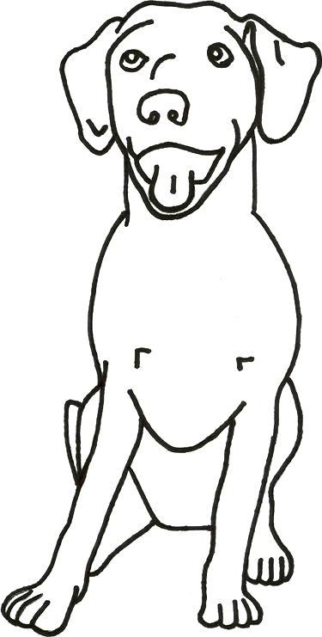

Front View of Statue
Right View of Statue

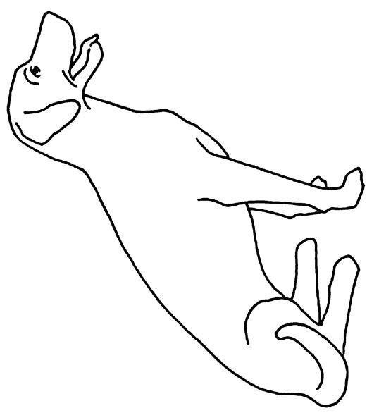

Left View of Statue

