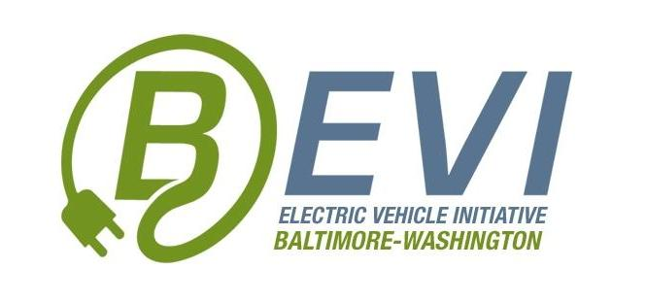
5 May=, 2017
Internship Coordinator: Jill Sorensen
Classroom: Maryland Institutions of Higher Education
Phone: 443-514-7122
E-mail: jatsorensen@gmail.com
EVEP Internship Description
BEVI, the Baltimore-Washington Electric Vehicle Initiative, is a non-profit focused on electric vehicle education and outreach. BEVI is looking for summer interns to advance our mission by joining our 2017 summer electric vehicle education program (EVEP). The objectives of the 2017 EVEP are to engage interns who will work from the UMBC campus on continuing EV education and outreach, with a special focus on supporting and improving the existing marylandEV.org website and related social media feeds, workplace charging, and urban planning for the emergence of EV mobility. EVEP interns will be expected to develop a summer electric vehicle work plan with supervision from BEVI. The work plan will target the core objectives of the 2017 EVEP Program, namely these:
- Improve the content on and user interface of the Statewide electric vehicle website, marylandEV.org, in collaboration with BEVI, UMBC and EV stakeholders, including institutions of higher education, local utilities, state agencies and industry;
- Engage social media and plan related communication campaigns, particularly for workplace charging outreach, for the purpose of maximizing education, outreach and idea exchange concerning electric vehicles; and
- Create three EV videos to help educate and promote EV adoption and use in Maryland.
A stipend of $2,500 will be provided to participants on a schedule and terms agreed upon between the student and their respective host institution. Work hours and attendance will be 9:00 a.m. to 3:00 p.m. Monday through Thursday. Students will be responsible for getting to and from internship meeting locations, which will be based at UMBC, but may change depending upon special local EV education outings or events. Accommodations will be made as needed for various summer schedules, doctors appointments, etc.
Internship Objectives and Internship Skills Sought
- UI/UX: Improve marylandEV.org website with current EV eduction content, better user interface and experience.
- Communication: Develop electric vehicle educational material to help inform others about electric vehicles and EV infrastructure (where to plug in to re-fuel). Build upon core social media communication systems for community EV readiness, information, news and events.
- Software and data analytics: Help plan and execute smart street light pilot in West Baltimore.
- Videography skills
- Survey research: Prepare for and launch smart street light survey of stakeholders for smart street light pilot in West Baltimore
- Economic and financial proficiency: Evaluate monetization strategies and business models to converge IT, clean energy and clean transportation infrastructure development of the proposed B’Smart Street Light Pilot in West Baltimore.

Intern Responsibilities / Attendance Policy
Interns are expected to attend all weekly webinars and online communications, complete scheduled activities before they are due so that group discussions will be productive, and participate actively during EVEP discussions and activities. If an intern is unable to participate in a particular week due to outside obligations or unforeseen circumstances, then the intern is required to coordinate make-up time with their host institution.

