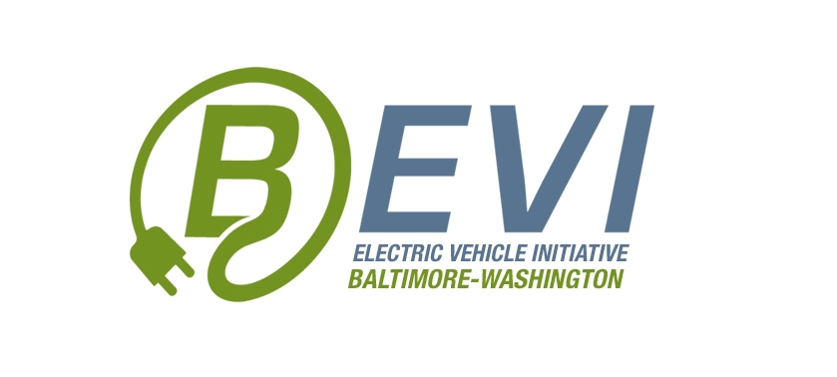

Baltimore Electric Vehicle Initiative (BEVI) 2017

EVEP Summer Internship Application Form

(Please use word processor or type)

STEP 1: Complete the following application on or before June 1, 2017. Then, mail, fax, or e-mail the application materials to BEVI (see next page for STEP 2 details).

FULL NAME:

E-MAIL ADDRESS:

COUNTRY OF CITIZENSHIP*:

* If not a US citizen, include visa type & expiration date, or note if you are a US permanent resident:

DATE OF BIRTH:

CONTACT TELEPHONE #(s):

PERMANANT ADDRESS PLUS SECONDARY CONTACT (NAME & RELATIONSHIP):
INDICATE WHY YOU WISH TO PARTICIPATE IN THE BEVI SUMMER INTERNSHIP AND THE AREA(S) OF INTEREST YOU WOULD LIKE TO CULTIVATE THROUGH YOUR PARTICIPATION:  (If interested in more than one field, rank highest 1, next-highest 2 etc) | UI/UX for marylandEV.org  Communication and outreach about EVs  Software and data analytics related to EV mobility and smart cities initiatives  Videography  Survey research, survey implementation and report/writing  Business and economic analysis about Internet of Things applications  Other (please specify)

NAME OF SPONSOR:

I certify that all BEVI Internship application information provided is true to the best of my knowledge. I understand that I am responsible for my own actions and participation in the EVEP internship, and have signed the attached EVEP Waiver and Release*.

(Please print out, sign and date)

STEP 2. Email the completed application, resume and cover letter to Jill Sorensen at “jatsorensen@gmail.com”:
E-mail application forms need to be signed, scanned, and then e-mailed to BEVI.

Jill A. T. Sorensen
Executive Director
Baltimore-Washington Electric Vehicle Initiative
111 S. Calvert Street, Suite 2310
Baltimore, Maryland 21210
m: 443-514-7122
jatsorensen@gmail.com
www.marylandEV.org

*BEVI EVEP WAIVER and RELEASE

I, _______________________ (insert name), acknowledge that my participation in the BEVI EVEP summer internship program (Program) involves exposure to the internet, collaborative work with my peers and mentors, and community outreach. I represent that I am fit and able to participate in the BEVI 8 week summer internship. I expressly assume all known and unknown risks associated with it, including but not limited to: injury, accidents, loss of or damage to my property, the effects of weather, scheduling interruptions and the like.
I UNDERSTAND AND HEREBY AGREE TO ASSUME ALL OF THE RISKS WHICH MAY BE ENCOUNTERED IN THE COURSE OF THE BEVI EVEP SUMMER INTERNSHIP ACTIVITIES INCLUDING ACTIVITIES PRELIMINARY AND SUBSEQUENT THERETO. I agree to hold BEVI and my Sponsor harmless from and against any and all liabilities, actions, causes of actions, claims, expenses, and damages suffered on account of any injury to me or my property which I now have or which may arise in the future in connection with my participation in the Program or any activities, acts, or events associated with it, including but not limited to any transportation provided or involved in the Program.
AGREED: _____________________ _________________ Intern name Date
PARENT or GUARDIAN AFFIRMATION:
______________________ ______________
Name Date

