Professional Staff Senate Meeting Minutes
Thursday, October 13, 2022
2:30 – 4:30 p.m. – Virtual
In Attendance: Link
Non-Officer Staff In Attendance:
Land Acknowledgement
UMBC was established upon the land of the Piscataway and Susquehannock peoples. Over time, citizens of many more Indigenous nations have come to reside in this region. We humbly offer our respect to all past, present, and future Indigenous people connected to this place.

- 2:35 p.m. Call to Order
Approve This Month’s Meeting Agenda
Approve Last Month’s Meeting Minutes

- 2:40 p.m. Staff Awards - Martina Buckley / Ray Soellner
  - Attempt to have a wide variety of representation on the awards committee, including reps from PSS, NESS, past award winners, etc.
  - Call for nominations goes through the month of October, with nominations closing on October 31st
  - Cross promotion through various outlets
  - Awards website: https://provost.umbc.edu/staffawards/
  - Distinguished staff award – requires 7 years experiencve vs 5 years for all other UMBC awards

- 3:00 p.m. Comms Committee Updates – Ally Hepp

- 3:10 p.m. Action Plan Planning – Jess Wyatt
  - Acknowledgment that there is a shift in the capacity of the individual committees to deliver “actions” and that it may not be possible in the same ways it has been in the past

- 3:15 p.m. Small groups

- 3:30 p.m. Homecoming Updates/Reminders - Jess Wyatt

2:40 p.m. Copy and paste agenda (shared by president prior to meeting)

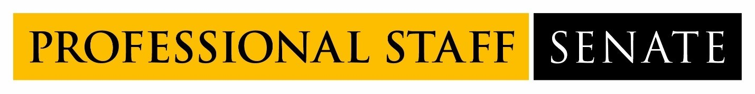
2022-2023 Professional Staff Senate Meeting Schedule
Meetings from 2:30PM – 4:30PM
July 14, 2022
August 11, 2022
September 8, 2022
October 13, 2022
November 10, 2022
December 8, 2022
January 12, 2023
February 9, 2023
March 2, 2023
April 13, 2023
May 11, 2023
June 8, 2023

