Professional Staff Senate Meeting Agenda
Thursday, August 11, 2022
2:30 – 4:30 p.m. – Virtual

2:35 p.m. Call to Order
Approve This Month’s Meeting Agenda
Approve July’s Meeting Minutes

- Next month:
VSA will be joining, so we’ll need to do some planning to make that an effective use of time.
- July’s minutes are approved.

2:35 p.m. Committee Assignments
- Everyone, please make sure to check on your committee assignments!
- If you have a conflict or think it won’t work out, please reach out to Jess & Ray.

2:45 p.m. Retriever Essentials with Lydia Sannella (Program Coordinator, and grad student)
- Slideshow presentation
- Food insecurity disproportionately affects different groups of students, those who have the most to benefit to getting a degree.
- Three main programs:
  - Foot distribution
  - Save a swipe
  - Towards Wholesome Eating
- Free to everyone on campus, there is a pantry for food, but also essentials like toiletries and baby items.
- Big things are coming!

3:00 p.m. Rec Sports with Joella Lubaszewski

- [presentation]

3:15 p.m. Retriever Peer to Peer Listening Program
Kim Leisey and Ileri Akinnola

LINK
ilerioa1@umbc.edu

- What it is:
  - A way to connect UMBC students – to others who will listen to them
  - It is inclusive of nearby commuters
- What it is not:
  - Emergency services, crisis situation support, not the substitute of the counseling center
- Considering two models:
  - Model 1: scheduling meet up in a place pre-arranged
  - Model 2: schedule a pre-set time and people arrive without pre arranging it
- Meetings:
  - Not in people’s private rooms
  - At night needs to have good lighting, public places
- This is not just an UG program

Biggest need:
Recruiting more peers – info on student affairs website under resources and all peers

3:30 p.m. Event & Conference Services with Matt Bolling

- Large scale events – they are not requiring masking
- Catering restrictions have been lifted and are back to maximums – biggest event space, the ballroom is back online, they can accommodate people now.
- All the spaces are also equipped with microphones/cameras and meet the "HyFlex" standard where all attendees can see/hear each other
- Reach out to his team:
  - https://eventservices.umbc.edu/
  - 410-455-3615
  - Contact Us

3:45 p.m. Campus Announcements

One Day. One Purpose – A Scholarship Initiative – August 31, 2022

Homecoming 2022

- Oct 7-16, 2022
- Many signature events returning from previous years (bonfire, Grit- X, carnival, etc)
- There will be volunteering opportunites

4:00 p.m. Brainstorm and Co-Create PSS Sept Agenda for Dr Sheares Ashby

- Senators may have the opportunity to show up in person in the UC. Ray prepared a poll to gauge interest:
  - The vote was overwhelmingly yes
- UC 310 and 312 are held
- Think about the process, the questions themselves

Reports back from breakout rooms:
- Having her ask us questions (she seems really interested in our stories).
- How often, and how would you prefer to connect with PSS?
- What is your vision for UMBC over the next 5-10 years? How do you envision staff supporting your vision?
- Given ongoing issues of staff retention both at UMBC and everywhere, what are some strategies on
- encouraging staff retention and attracting qualified talent?
- How does she view her role interacting with the various senates?
- How can UMBC deal with the expected influx of international students?
- Describe your experience with shared governance? How can PSS be supportive in her first year and beyond?
- What specific plan are there to respond and prepare for the “demographic cliff?”
- How to format the session:
  - assign questions, perhaps related to committee assignments
  - We think that it would be a good idea to provide the questions to her in advance.
  - Let her ask questions of PSS as well

Sarah raised a good question: How should PSS approach what we do with the information we receive in senate meetings?

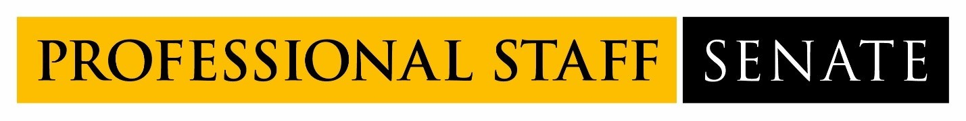
2022-2023 Professional Staff Senate Meeting Schedule
Meetings from 2:30PM – 4:30PM
July 14, 2022
August 11, 2022
September 8, 2022
October 13, 2022
November 10, 2022
December 8, 2022
January 12, 2023
February 9, 2023
March 2, 2023
April 13, 2023
May 11, 2023
June 8, 2023

