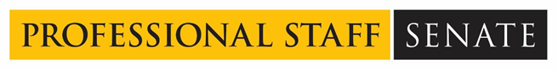
Professional Staff Senate Meeting Minutes
Thursday, July 14, 2022
2:30 – 4:30 p.m. – Virtual
In Attendance: Link
Non-Officer Staff In Attendance: Dennis Cuddy
Land Acknowledgement
UMBC was established upon the land of the Piscataway and Susquehannock peoples. Over time, citizens of many more Indigenous nations have come to reside in this region. We humbly offer our respect to all past, present, and future Indigenous people connected to this place.

2:35 p.m. Call to Order
Approve July’s Meeting Agenda
Approve June’s Meeting Minutes

2:45 p.m. Ryan Sheldon, Center for Global Engagement
- Needs two in-home hosts for Azerbaijan visiting professionals
- Ryan is from the English Language Institute (ELI), sheldo1@umbc.edu
- Primary mission: intensive English program for future UMBC students who need additional support in language development
- Group of professionals from Azerbaijan arriving next week and their charge is educational and employment opportunities
- Because of the style of grant that this is, there is no stipend for hosting. Hosts will house these students, including weekends, and should plan to take them out on the weekend. Hosts are expected to provide breakfast and dinner for these students
- Basic pickup and drop off at 9 a.m. and 5 p.m. for the week that they are doing the program
- There will be additional opportunities to host later this year

3:00 p.m. Elections
- President - Jess Wyatt
- Vice President - Ray Soellner
- Treasurer - Cael Mulcahy
- Co-Secretary - Bryan Barnes
- Co-Secretary - Simon Reilly
- Communications Officer – Ally Hepp
- All positions running unopposed and elected

3:30 p.m. Committee Selections – Fill out THIS FORM
- Assignments will be distributed by August 4, 2022

3:40 p.m. PSS Internal Communications Practices
- Small group discussions, email Jess with discussion notes

4:00 p.m. Bless Mission/Vision Statement
- Vision Statement - Approved
The Professional Staff Senate (PSS) plays an integral role in the advancement of UMBC’s mission by making UMBC a great place to learn, work and grow as global citizens. Through the advocacy of Staff at UMBC, we provide the support that Students, Faculty, and Staff need to thrive in their roles.
- Mission Statement – Approved
The Professional Staff Senate (PSS) is a committee of dedicated staff who advocate for the wellbeing of all exempt staff across UMBC to the administration. PSS will work to provide creative solutions to the challenges staff are facing. PSS builds relationships throughout all areas of the campus to uplift the whole community and advance our institution. We do this by developing thoughtful programming and events that support our campus community, promoting personal and professional development opportunities, facilitating communication of staff interests between campus leadership and our constituents, and by building a network of staff committed to supporting one another and UMBC as a community.

Updates from Group
- Notes from Ray:
  - Hoping to have a new HR leader in mid-September
  - Upgrade your Webex app, Webex Meetings is going away
- 2022 Cookout Recap
  - Problems:
    - Catering manager turned over a couple of times before the event
    - Events and conference services were not listening to Ally’s direction initially - but Simon stepped in to help get things aligned.
  - 14 raffle prizes, some are still being picked up
  - 50+ people registered online for raffle items
  - 250+ people in attendance

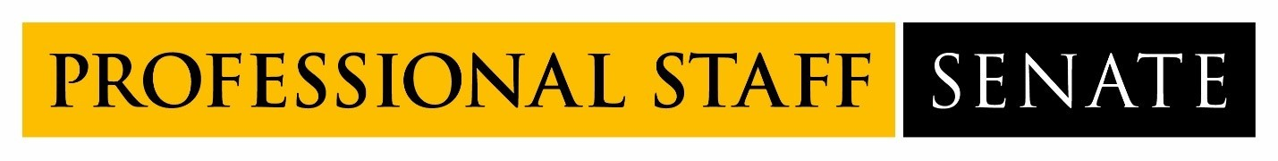
2022-2023 Professional Staff Senate Meeting Schedule
Meetings from 2:30PM – 4:30PM
July 14, 2022
August 11, 2022
September 8, 2022
October 13, 2022
November 10, 2022
December 8, 2022
January 12, 2023
February 9, 2023
March 2, 2023
April 13, 2023
May 11, 2023
June 8, 2023

