Professional Staff Senate Agenda  Thursday, October 14, 2021  2:30 – 4:30 p.m. – Virtual | 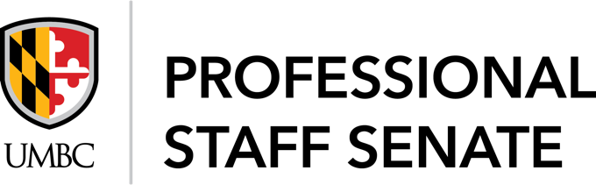

Check-in Generator Question: What is a recent non-work success you’ve experienced? (Answer in the chat)

UMBC was established upon the land of the Piscataway and Susquehannock peoples. Over time, citizens of many more Indigenous nations have come to reside in this region. We humbly offer our respect to all past, present, and future Indigenous people connected to this place.

In Attendance: Link

2:35 p.m. Call to Order
Approve October Meeting Agenda
Approve September Meeting Minutes

2:40 p.m. Presidential Search Updates
    - Met with the Chancellor to discuss what is important to us
    - Somewhat dominated by faculty side on the first meeting, so PSS and NESS was able to have a second meeting to share perspective on staff side
    - What was discussed – pipeline/lack of upward mobility, how the university (students) has been growing but not the same is happening for staff, continuing to build on our strengths
    - Congrats to Bea for being selected to be part of the Presidential Search Committee!

2:45 p.m. Emergency Preparedness
John Schaible, Emergency Manager, UMBC Police Department
- Community RISK survey
- Every year the university does this to assess what the threats are, accidental, natural hazards, and man-made hazards, etc.
- Extending the assessment on what our concerns are on safety and security to a wider audience (is going around all the governance groups on campus, next week will be going to SGA)
- Looking for a strategy to send the survey out and receive feedbacks
- Poulomi Banerjee suggests using the PSS myUMBC and adding it to the next PSS Newsletter
- Looking to get this out to staff, faculty and students
- Kait McCaffrey mentioned this can be sent out using the University social main channels
- The survey is generalized—you don’t need specialized knowledge, interested in people’s individual opinions regarding hazards
- Sarah Hansen: How will the responses be useful?
- Doing it 2 ways, wider community survey and a separate one for folks with specialized knowledge
- Assess the gaps from the people who know and those who don’t – in order to inform him how to move forward via training and processes
- QR Code might be a good way to reach students
- He would like to come back to keep us informed on initiatives happening
- FEAPs (Facilities Emergency Action Plans) – one document that includes processes regarding facilities
- Continuity of Operations – pushing for a robust true continuity plan, so folks from different offices may be pulled in for this
- That’s all that is happening in Emergency Management

3:00 p.m. Critical Social Justice
Amelia Meman (they/she) is our guest speaker for today’s presentation

Women’s Center Updates
- Crip Camp Screening + Discussion
- 10/27, Wednesday, 3 – 6pm, online via Google Meet
Vote on CSJ Co-Sponsorship
- Motion to become a co-sponsor for CSJ (second)
- No opposition
- Motion passes!

3:30 p.m. Small Group Discussions
What is one thing that was new/surprising?
Choose a note-taker/facilitator

10 minutes for Small Group discussions

Accessibility at UMBC – How can we bring this lens to our committee work and PSS as a whole?

Small Group notes are being sent to Jess

3:45 p.m. Action Plan – Does this align with what we discussed?
Vote to approve

Ken Schreihofer (Question):
- Do you think this reflects our priorities in terms of what we are looking for in our future president and what our staff needs are?
- What are we going to actually do? There are good statements here, but they are broad and its missing action steps
- PSS Exec meetings having committee chairs attend might help with this
- We can also have committee chairs draft their own action steps

Motion to approve Action Plan 2021 – 2022
Motion seconded

Motion passes!

4:00 p.m. Committee Report Outs
Mentoring
- Going to be hosting our first mentoring workshop
- Virtual panel
- Will be open more broadly
- Afterwards there will be an in-person meeting for folks to drop-in have some snacks and meet with mentor/mentees
- Another workshop will be done in the spring
- If you are a mentor, you should have funds now so you can take your mentee to get some coffee or snackage
CUSS
- CUSS Action Plan is going to be voted on soon (at next meeting)
- Went to student council meeting, will be going to the faculty one soon to share
- We are not going to be the only campus searching for a president (Salisbury)
- Got to go to the Board of Regents retreat (to set the new regents up for success—what is their crisis/emergency plan, how they connect with presidents and the chancellor)
- Happy to share materials from the retreat for those who may be interested (email Laila)
- Will share Action Plan soon once its approved!
SOD
- Grouping together on the Meet & Greet with Laila, giving out snacks
- Halloween Costume Picture Contest, deadline 10/22
  - Send through Goggle from Poulomi
  - Officer Chip and Cheatem will be voting for the winners
- Near future plans (early 2022):
  - Work/Life Balance for massages later in the year
  - Working on Professional Head Shots for staff
PRC
- Met on October 4
- One of their action items is to meet with Val Thomas to discuss possibly revamping the PMP (first Monday of the month of November)
- New HR member will be at the meeting as well
- Employee reporting to be included ideally
- Envision using DocuSign and adding position descriptions
- Looking into adding some professional development
- Having staff member and immediate supervisor do their own separate evaluations and then coming together in a meeting to discuss both evals to submit together officially through the PMP
- This is something that has been done in some areas, but not all
- If anyone has any questions or advice to add to the discussion email Justine Johnson
- Concern about updating position descriptions (Elle Trusz): Has seen that when it comes time to get a raise for their position that they need to see what was the previous position description vs the updated one
  - Only way to get promotion is via reclass
  - PRC is trying to partner with HR
  - If the position description is drastically different from original to updates, it should automatically trigger a reclass

Senator Share Out

Community Notice Board//Open Forum
- Starbucks Truck: Lot 8 Mon – Thurs, 8 a.m. - 1 p.m.
- Sunday, Oct 17, Noon – 5 p.m. Arbutus 125th Birthday Celebration
- Oct 18 – 20, National Health Education Week
- Oct 20, 3 – 4 p.m. Free Webinar: The True Impact of Digital Accessibility
- Oct 20, 6:30 p.m. Alumni Awards: Live Stream Available

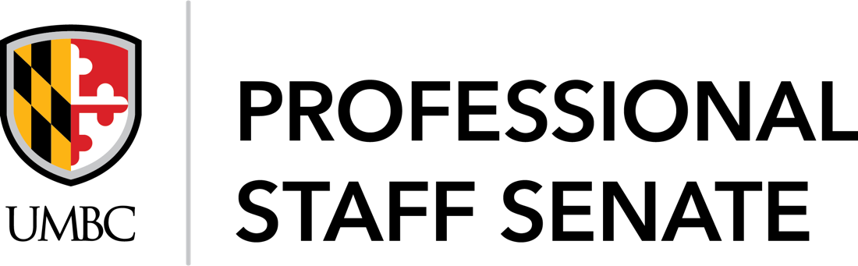
2021-2022 SENATE MEETING SCHEDULE
Meetings from 2:30PM – 4:30PM
July 8, 2021
August 12, 2021
September 9, 2021
October 14, 2021
November 11, 2021
December 9, 2021
January 13, 2022
February 10, 2022
March 10, 2022
April 14, 2022
May 12, 2022
June 9, 2022

