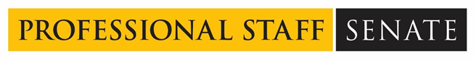
Professional Staff Senate Meeting Minutes
Thursday, September 9, 2021
2:30 – 4:30 p.m. – Virtual
In Attendance: Link
- Call to Order – 2:35pm
- Approved September 2021 Meeting Agenda
- Approved August 2021 Meeting Minutes
- Break Out Group Facilitation Volunteers
  - Vlad, Simon, Justine, and Rebecca will be group leads
- Committee Report Outs
  - Communications Committee
    - Not creating Instagram account for PSS because it would take a while for the page to get a following. Instead, we will use the Institutional Account which has almost 10,000 followers.
  - Personnel Review
    - The group met last Friday; will now meet monthly
    - Discussed making the PMP process a two-way document between employee and supervisor – rather than only your supervisor evaluating you, we would like to see there be a space for employees to evaluate themselves, their role, and set goals for themselves.
    - Timesheet pages now require employees to indicate if you’re working on campus or teleworking. We want to know how this data will be used and why they are asking for this information
  - If you are a non-senator but are still interested in serving on a committee, reach out to Jess or Ray and tell them which ones you’re interested in
- Pronouns & Gender Identity – Ever Hanna, Training and Case Manager, OEI
  - Increasing data shows the more someone’s identity is affirmed and pronouns they ask be used are used, the lower the rates of them attempting suicide.
  - In summer 2020, UMBC launched a new, streamlined process for students to update their name and pronouns; can choose up to 3 pronouns in system
  - When you slip up and call someone the wrong pronoun, correct yourself briefly and keep going! Avoid apologizing profusely.
  - When in doubt, avoid using pronouns! You can say “that student” or use their name. Ask what their pronouns are once you can.
  - Use the term “non-binary pronouns” vs “gender neutral.” Never say “preferred pronouns” - that is their identity, not a choice
  - Here is the PowerPoint if you would like to review!
- Presidential Transition – Candace Dodson-Reed
  - The selection and appointment of a university president is, by law, the responsibility and prerogative of the USM Board of Regents. The USM provides a procedural framework for the search and selection of university presidents within the USM.
  - USM will be hosting a town hall in the RAC, and there will be a virtual option as well. Staff will be able to talk to the Chancellor on dreams, hopes, and thoughts on their next leader for President. A search committee has not been formed yet. Search committee meetings will happen on campus, so there will be additional opportunities for your voice to be heard.
  - There will be celebrations for Freeman next semester!
  - https://president.umbc.edu/search/
- Action Plan & Return to Campus – Small Group Discussions
  - We reviewed action plan again in small groups because we have all gone though the transition of coming back to campus, seeing students, etc and everything feels different now.
  - How can we as a Senate be working toward supporting staff whose wellbeing has been impacted over the past year? How do we build a new, a better place to work vs. new normal
  - The Executive Board will collect these notes from the small group discussions and put it together
- Senator Share Out – Ray, Poulomi, and Vlad
  - Looking at your whole life, not just your work life, what is an activity you would enjoy spending the majority of your time? Why?
  - Poulomi: Travel and content creation
  - Ray: Travelling and camping experience
  - Vlad: Investing in relationships with people throughout his life
- Community Notice Board - Tyler Fultz
  - Retriever Courage Advisory Committee
    - Recruiting staff to join the committee, and there is a vacancy for co-chair
    - To read more about Retriever Courage, click here.
    - If you are interested in joining, please contact Tyler at tfultz@umbc.edu
- Meeting Adjourned at 4:31pm.

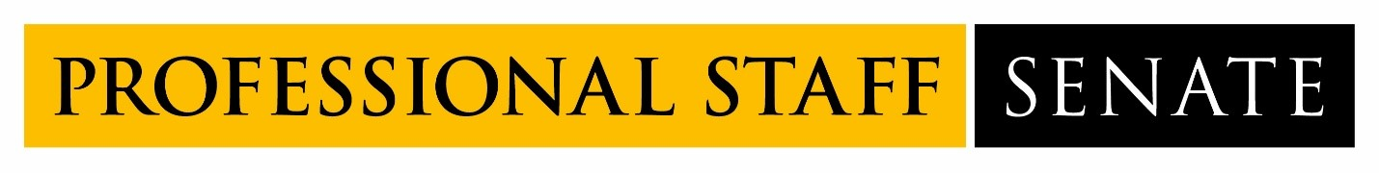
2021-2022 SENATE MEETING SCHEDULE
Meetings from 2:30PM – 4:30PM
July 8, 2021
August 12, 2021
September 9, 2021
October 14, 2021
November 11, 2021
December 9, 2021
January 13, 2022
February 10, 2022
March 10, 2022
April 14, 2022
May 12, 2022
June 9, 2022

