Professional Staff Senate Meeting Minutes
Thursday, August 12, 2021
2:30 – 4:30 p.m. – Virtual
In Attendance: Link
Non-Officer Staff In Attendance: Amelia Arria, Natalia Panfile, Carlos Turcios, Laura Taylor, Brittny McGowan, Sue Plitt, Molly Mitchell, Ashley Meyers, Joel DeWyer, Kelsey O’Hara, Marlayna Demond, & Monda Ahmad

- Call to Order: 2:37pm
- Approved [Previous Month’s 202X] Meeting Agenda [hyperlink]
- Approves [Previous Month’s 202X] Meeting Minutes [hyperlink]
2:35 p.m. Call to Order
2:40 p.m. Approve August Meeting Agenda
Approve July Meeting Minutes
2:45 p.m. Maryland Collaborative and the MD Alcohol Survey
- Amelia Arria
- Survey started in 2012 to track students’ cannabis and alcohol consumption and how we can intervene
- About 4200 students, 700 UMBC
- Many students found themselves drinking alone last year (~40%) where in the past, students of legal age were more likely to drink off-campus with others
- The evidence shows environment really matters – alcohol access and accessibility is a key factor
- UMBC students tend to use cannabis more than alcohol; not many binge drink
- May create agreements with local bars to ensure bartenders are not overserving our students and making sure they are practicing safe drinking
3:00 p.m. Committee Assignments
-you will be hearing from your chair soon to set up a meeting
3:15 p.m. PSS Action Plan Planning
- Broke into groups to make adjustments to action plans for the year
- Support, Community, Advocacy, and Development
- Some key topics:
  - Name Change to Exempt Staff Senate
  - Senate compensation
  - PMP training for supervisors
  - New timesheet indicator
  - Clearer advancement opportunities
  - Equity in professional development across units
  - Equity in flexibility as we move toward hybrid work environment
- The exec group will compile all of this and will be sent out
3:45 p.m. Committee Reports & Future Reporting Out
We want more accountability for accomplishing things
Jess and Ray may be reaching out to you a couple times throughout the year to receive updates on action items throughout year.
4:00 p.m. Cookout Updates
Rebranding from “picnic” to “cookout” due to the racist terminology
Cookout will be Friday, August 13th under the commons terrace tent
BBQ food with vegetarian options
Virtual raffle ticket options
Sign up sheet for volunteers has gone around. Have to wear a mask in line and bring your campus card for swiping in

4:15 p.m. PSS Engagement Ideas for Future Meetings
    - Self-Care Series 2.0: How to continue well-being in a hybrid world; shifting from working from home to campus/office days
      - If you know someone who would be good to speak on these topics, please send their contact information to Jess
    - DEI Topics
      - Pronouns/Gender Identity
      - Land Acknowledgements
      - Black History Month
      - LGBTQ+
      - Juneteenth
      - Disability Awareness/Ableism
      - Immigrants
    - Community Bulletin Board
      - Newsletter and space in meetings; things going on on campus
      - Examples: Laila and jess will be teaching fitness classes this fall!
    - Senator Spotlights – sign up to speak about cool things going on in your life!
  - Adjourned at 4:27

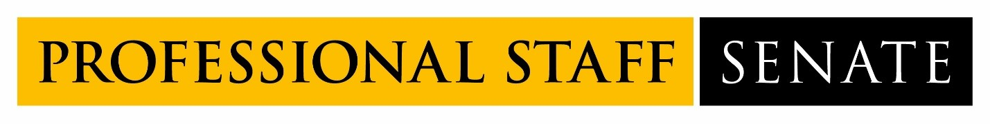
2021-2022 SENATE MEETING SCHEDULE
Meetings from 2:30PM – 4:30PM
July 8, 2021
August 12, 2021
September 9, 2021
October 14, 2021
November 11, 2021
December 9, 2021
January 13, 2022
February 10, 2022
March 10, 2022
April 14, 2022
May 12, 2022
June 9, 2022

