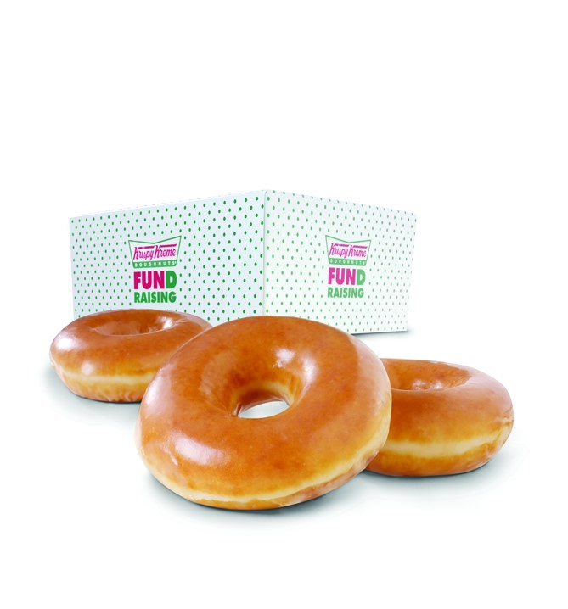
CAN YOU HELP US RAISE SOME DOUGH?
Doughnut Sales Order Form
Hello, I’m

from
I’m selling Krispy Kreme Original Glazed
®
dozens to raise money for
Name
Name of organization
Purpose of sale
UMBC
Psi Chi
Krispy Kreme Original Glazed® dozens sell for a price of $9 each.
CUSTOMER NAME AND ADDRESS | DOZENS PURCHASED | AMOUNT COLLECTED
TOTAL NUMBER TOTAL MONEY
PURCHASED COLLECTED
ITEM #80212 ©2013 KKDC

