DCOM Clothing Order Form
Please hand in completed forms to a DCOM officer by Friday October 6th, 2017!

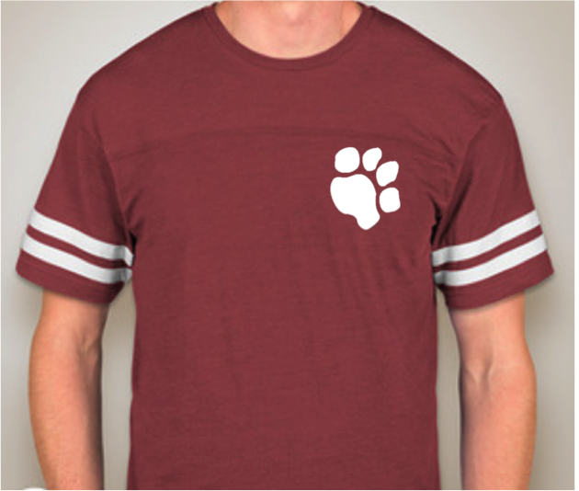
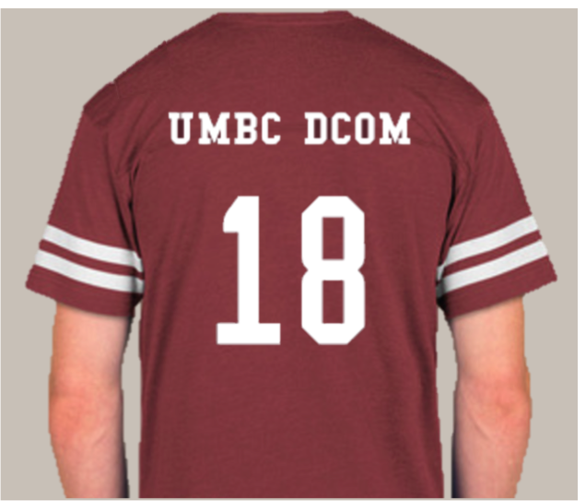
Maroon Varsity T-shirt with
White Text/Design
#_____ Adult Small x $15 = $______

#_____ Adult Med x $15 = $______
#_____ Adult Large x $15 = $_____
#_____ Adult X Large x $15 = $_____

Total = $________
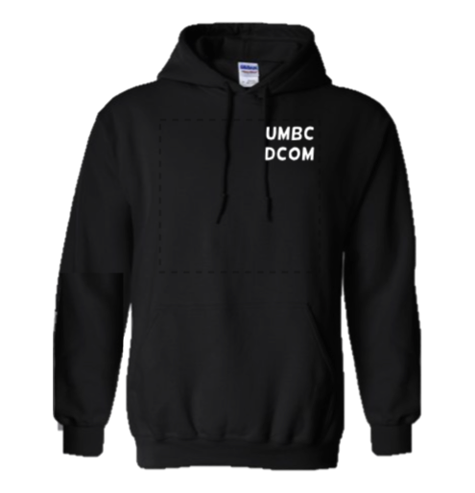
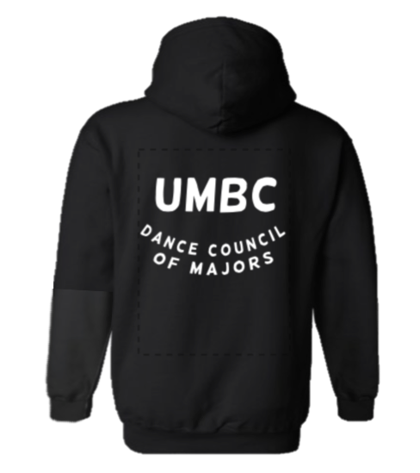

Black Hoodie with White Text
#_____ Adult Small x $25= $_____
#_____ Adult Medium x $25= $_____
#_____ Adult Large x $25= $_____
#_____ Adult X Large x $25= $_____

Total = $________

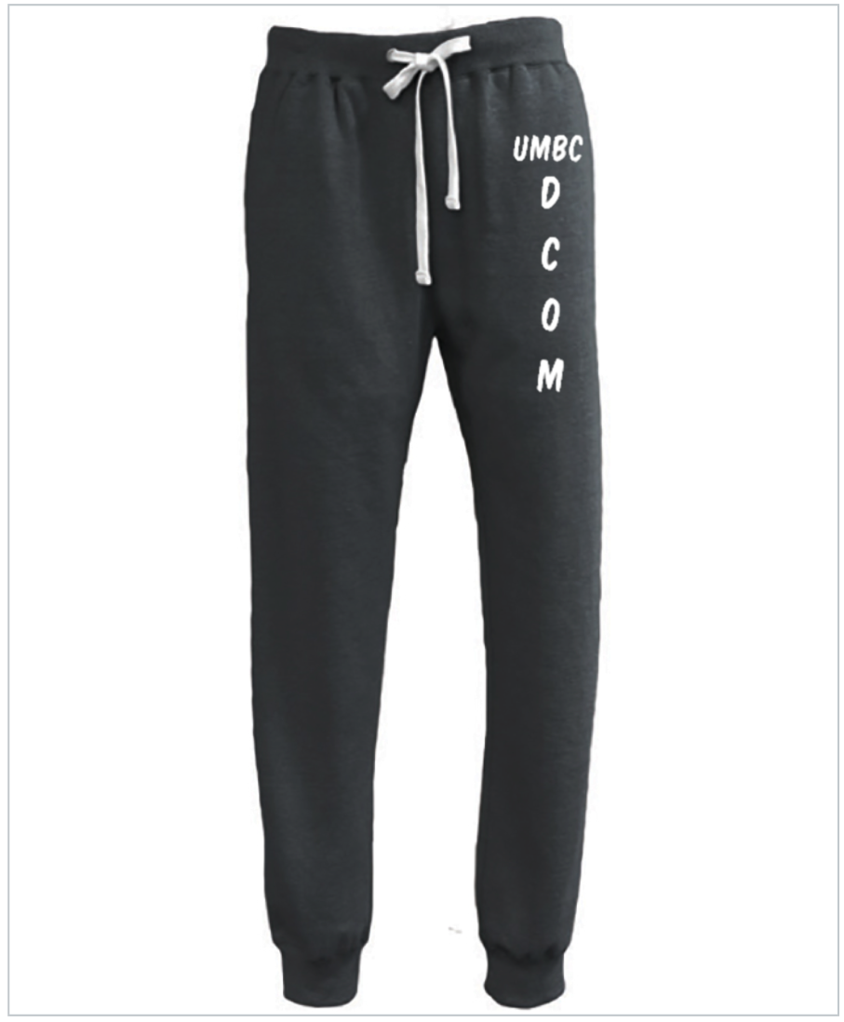

Black Heather Sweatpants with White Text
#_____ Adult Small x $30= $_____
#_____ Adult Medium x $30= $_____
#_____ Adult Large x $30= $_____
#_____ Adult X Large x $30= $_____

Total = $________

Name: _________________________ | Shirt Total | = $________
Email: _____________________________ | Sweatshirt Total | = $________
Phone Number: _____________________ | Sweatpants Total | = $________
 | Grand Total | = $_________

Cash or check only, cash preferred. Please make checks out to Marissa Gabel. You can give the completed form and money to Melissa Hudson, Maia Schechter, Kasey Mannion, or Marissa Gabel.

