American Society of Mechanical Engineers T-Shirt Fundraiser

The American Society of Mechanical Engineers (ASME) UMBC Chapter is selling UMBC Engineering t-shirts to raise funds for their Fall 2012 semester projects/events. Projects include the designing and building of a Mini-Bike and Dunk Tank. Events include an Interdisciplinary Panel Night, a Speed Networking Event as well as outreach programs to inspire future engineers!

Please return the order form and either cash or check (made payable to ASME UMBC) to commons organization mailbox number 21 (located on the second floor of the Commons, at the entrance of the Student Organization space, next to the game room) or to Dr. Anne Spence’s mailbox at the Mechanical Engineering department office in the Engineering Building on the second floor.
Please put order form and cash/check in an envelope and label it “ASME Fundraiser.” Order forms are due by October 31st!

When the t-shirts arrive an e-mail will be sent out for location pick up times and location. Please bring a form of ID when picking up your shirt.

NAME: __________________________
E-MAIL: _________________________
PHONE: _________________________

SIZE (S-2XL) | QUANTITY | PRICE ($12 per shirt)

TOTAL PRICE: _________________

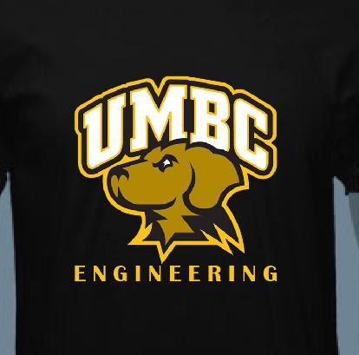
Front of shirt

